**DAB 201 Final Exam Assignment- Winter 2020**

**Due April 16th by 11:59PM.**

*You are asked to create a story in Tableau with 2-6 sheets and one dashboard.*

**Instructions:**

1. Create 2-6 sheets, depending on your dataset.
2. Create One dashboard
3. Add Captions to highlight importance of items, name all report elements accordingly
4. Choose **3 different** visualizing types to illustrate any findings in your data. (Line Char, Bar Chart, Pie, Donut, Scatter, bubble Chart, Treemap, Heat Map, Maps or Waterfall chart)
5. One Animation: here is an example <https://www.youtube.com/watch?v=yxRnk7fE-J0>)
6. Publish to Tableau Public: here are instructions on how to do that [help.tableau.com/current/guides/get-started-tutorial/en-us/get-started-tutorial-share.htm](https://help.tableau.com/current/guides/get-started-tutorial/en-us/get-started-tutorial-share.htm)

**To Submit:**

* Word document
  + Link to your Tableau public report publication
  + Screenshots of all report visualization

**Notes:**

**Please note plagiarism will not be tolerated.

**Datasets (**If your project was about COVID19, you may choose ANY dataset found in Kaggle, Google Dataset search)**:**

<https://www.kaggle.com/imdevskp/corona-virus-report>

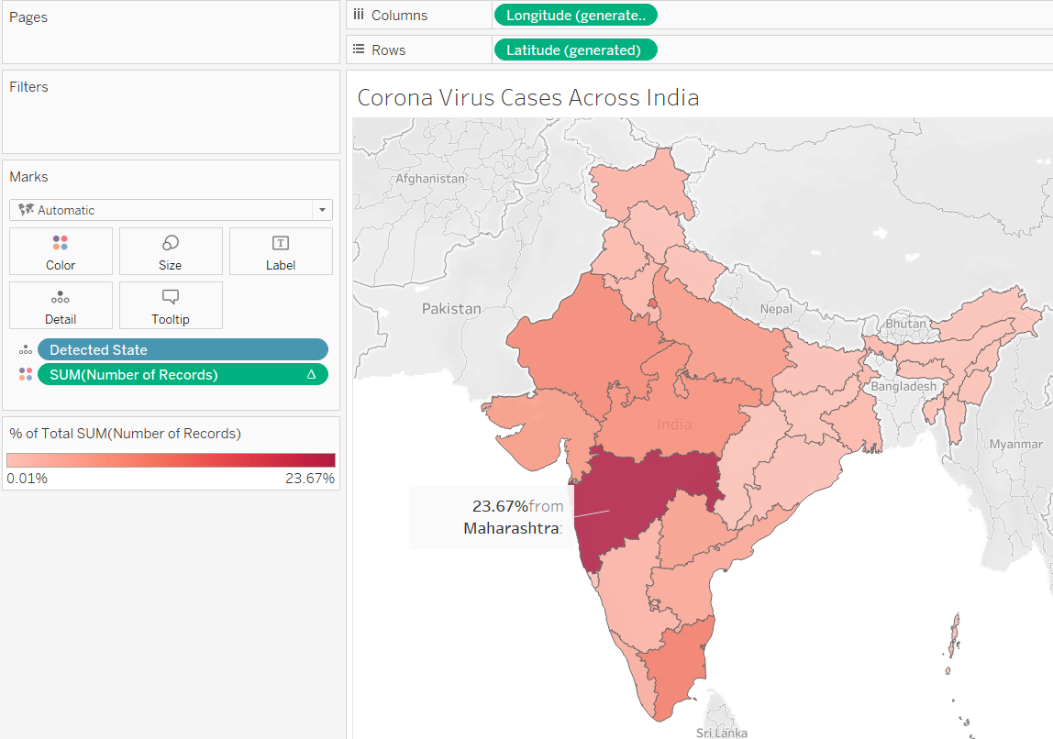



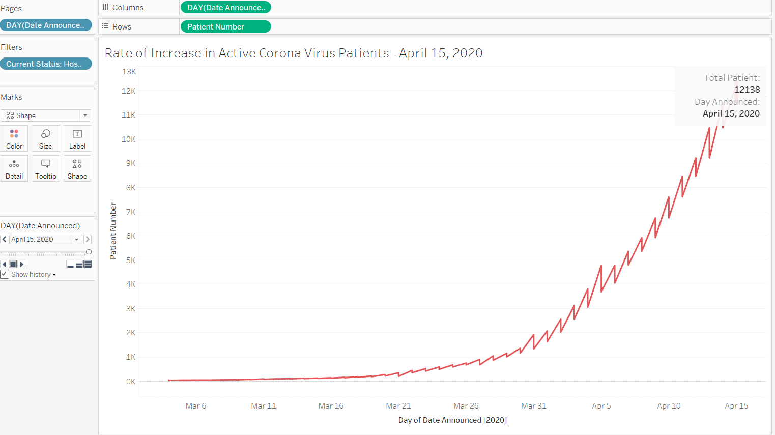

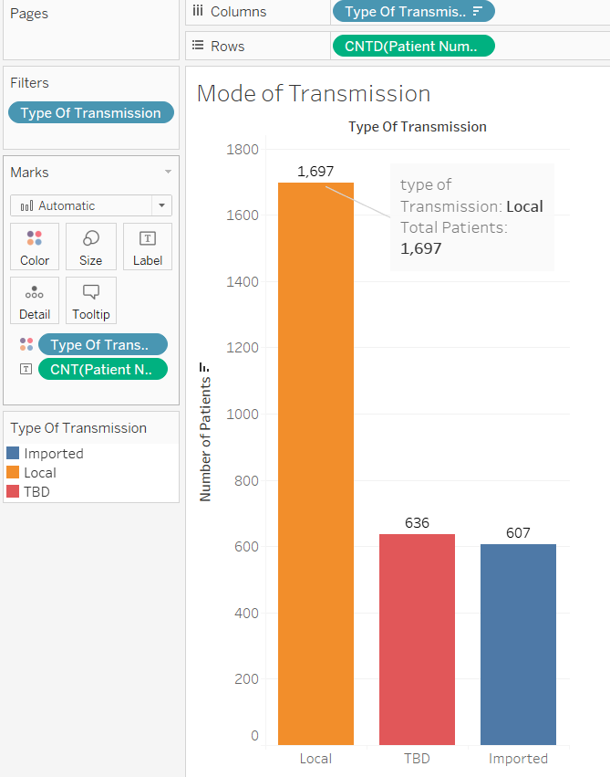

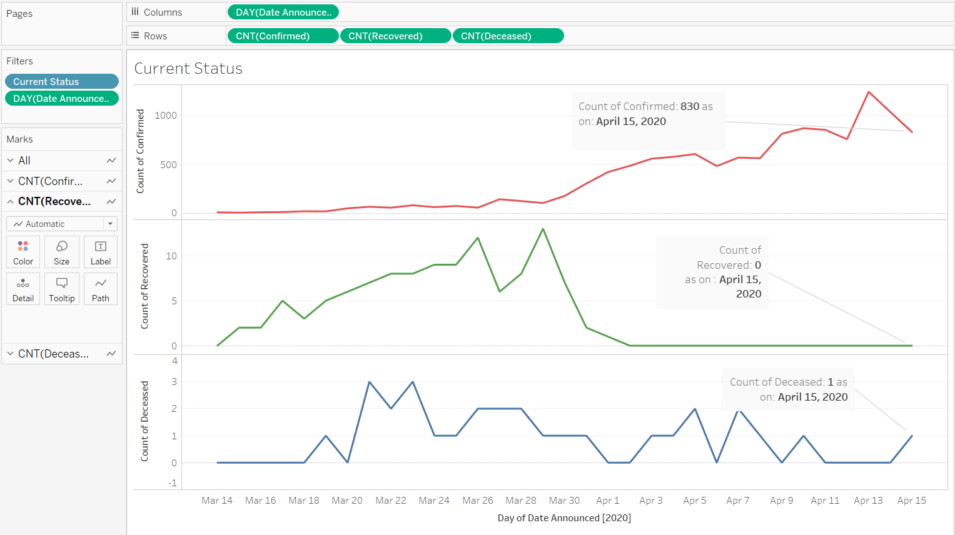

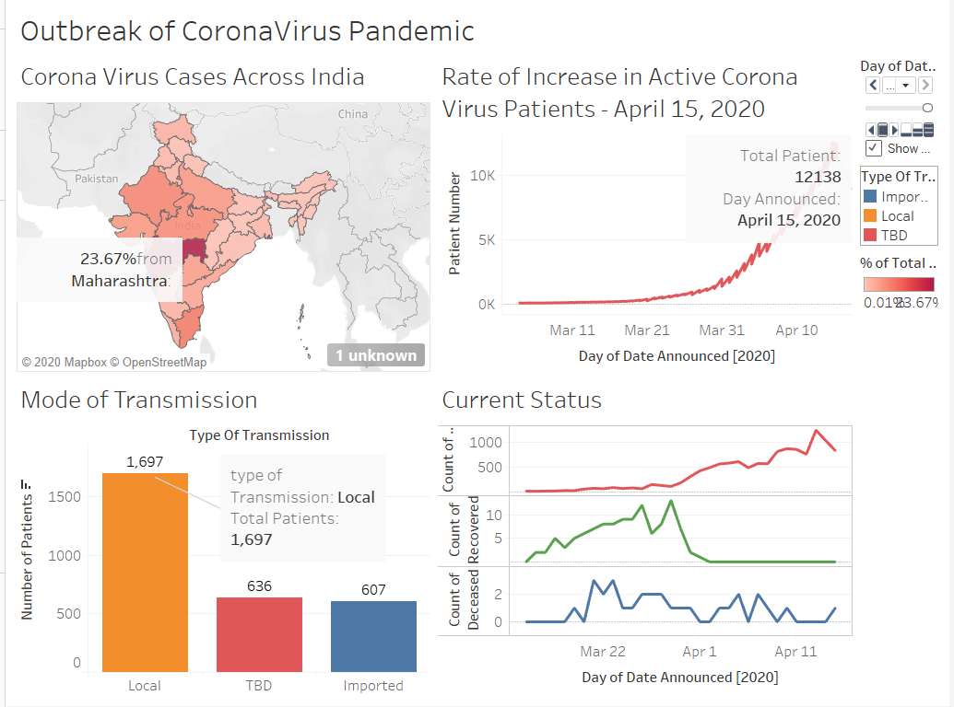

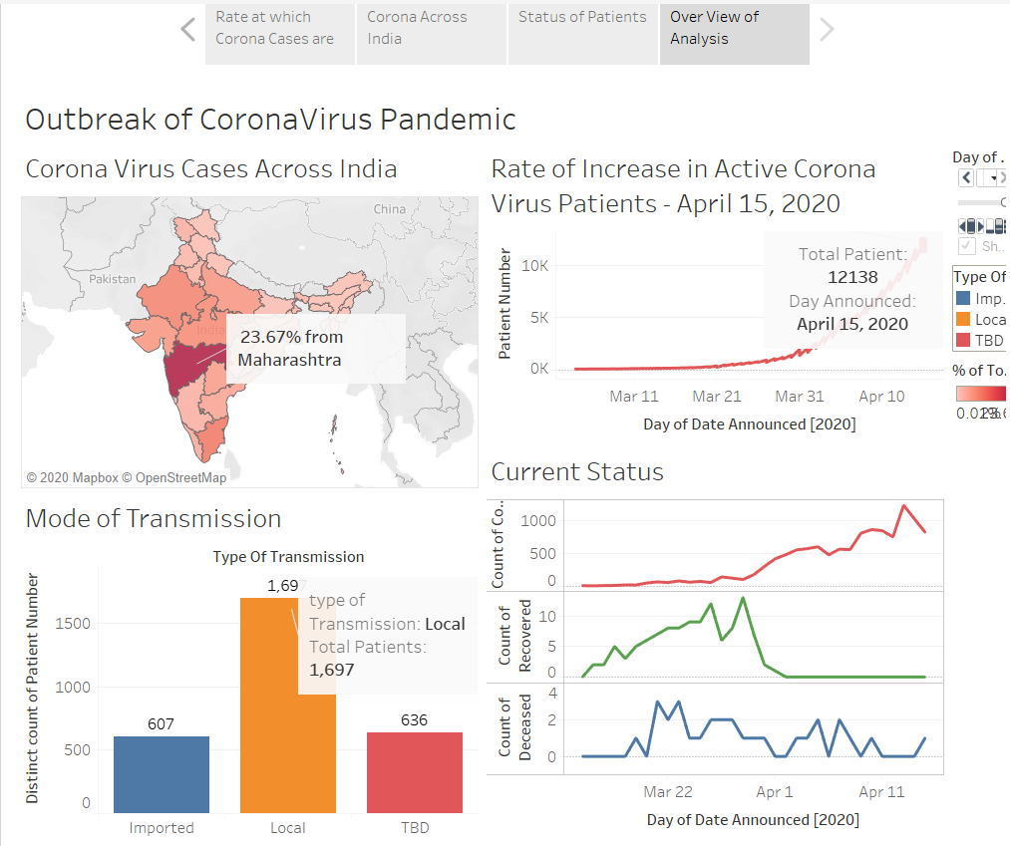

Above one is the span of story

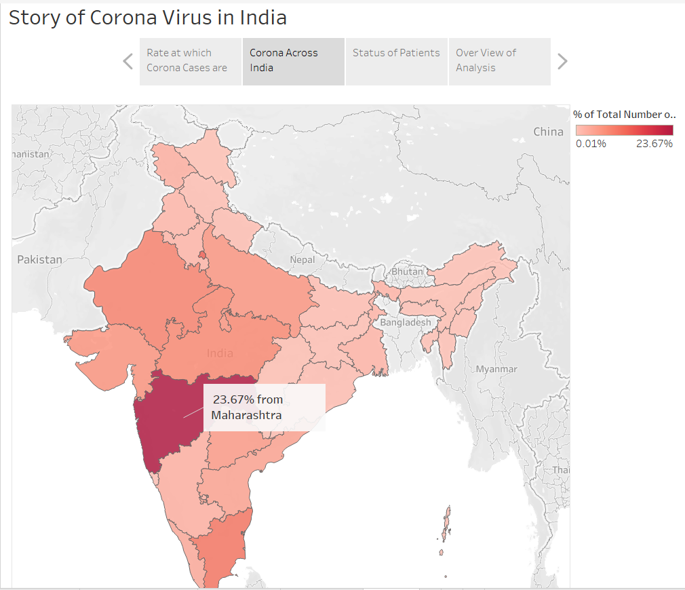

**Sheet 1:** https://public.tableau.com/profile/siddhesh7238#!/vizhome/CORONA_INDIA/IndiaMap?publish=yes

**Sheet 2:**

<https://public.tableau.com/profile/siddhesh7238#!/vizhome/CORONA_INDIA/Animated_chart?publish=yes>

**Shee3:**

<https://public.tableau.com/profile/siddhesh7238#!/vizhome/CORONA_INDIA/ModeofTransmission?publish=yes>

**Sheet 4:**

<https://public.tableau.com/profile/siddhesh7238#!/vizhome/CORONA_INDIA/CurrentStatus?publish=yes>

**Dashboard link:**

<https://public.tableau.com/profile/siddhesh7238#!/vizhome/CORONA_INDIA/Dashboard1?publish=yes>

**Story Link**:

https://public.tableau.com/profile/siddhesh7238#!/vizhome/CORONA_INDIA/Story1?publish=yes

